**PT 3 – PE**

A bank has several automated teller machines (ATMs) that are geographically distributed and connected via a wide area network to a central server.

The customer via ATM can withdraw funds from a checking or savings account, query the balance of the account, and transfer funds from one account to another. In order to execute each of these activities, the customer has to insert credit card for validating the customer’s PIN.

Task 1: Draw the Activity Diagram for the Validate PIN UC that deals with reading the ATM card, validating the customer’s PIN and card. If validation is successful, the system prompts the customer to select a transaction: withdrawal, query, or transfer. The alternative branches deal with all the possible error conditions, such as the customer enters the wrong PIN and must be re-prompted, or an ATM card is not recognized or has been reported stolen, and so on..

Task 2: Draw the Swim-Lane Diagram for this process.

Task 1:  
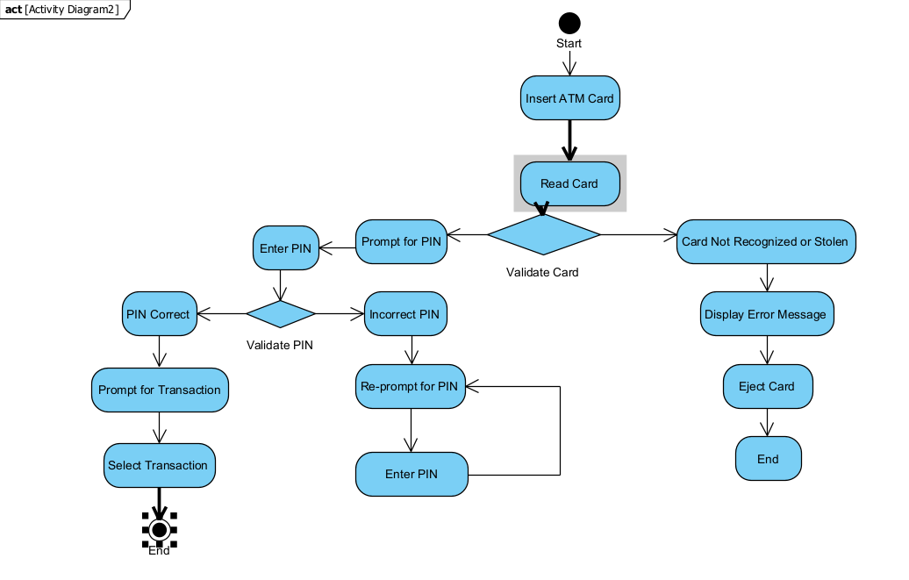

Task 2:  
